DATE:
Online Library Management System
1. Aim
To design and develop an Online Library Management System using HTML, CSS, JavaScript, PHP, and MySQL. The system allows students to search for books, view borrowing history, check fines, and download study materials. It also enables the librarian to manage books, issue and return books, calculate fines, and upload study materials.
2. Software Required
- Operating System: Windows
- Front-end Technologies: HTML5, CSS3
- Programming Language: JavaScript, PHP
- Database: MySQL
- Code Editor: Visual Studio Code
- Web Browser: Google Chrome
3. Algorithm
- Start the program and design the library website using HTML and CSS.
- Create registration and login pages for students and librarians.
- Allow students to search for books and view book details.
- Provide a student dashboard to view borrowing history, issue dates, due dates, fines, and profile details.
- Develop an admin dashboard to add, update, and delete books and issue books to students.
- Allow the librarian to update book return status and calculate fines for overdue books.
- Provide options to upload, update, search, and download study materials based on academic year and semester.
- Connect the website to the database, test all functions, and display the results.

Code:
HTML
<!DOCTYPE html>
<html lang="en">
<head>
<meta charset="UTF-8">
<title>College Central Library</title>
<link rel="stylesheet" href="style.css">
</head>
<body>

<header>
<h1>Campus Central Library</h1>
<nav>
<a href="index.html" class="active">Home</a>
<a href="login.html">Login / Register</a>
<a href="student_dashboard.html">Student Portal</a>
<a href="admin_dashboard.html">Admin Portal</a>
</nav>
</header>

<div class="container">
<!-- Search Section -->
<div class="card">
<h2>Search Library Catalog</h2>
<form action="#" method="get">
<div class="form-row">
<div class="form-group" style="flex: 2;">
<label for="search">Title, Author, or ISBN</label>
<input type="text" id="search" placeholder="e.g., Computer Networks, Tanenbaum...">
</div>
<div class="form-group" style="flex: 1;">
<label for="dept">Department</label>
<select id="dept">
<option value="all">All Departments</option>
<option value="cse">CSE / IT</option>
<option value="ece">ECE</option>
<option value="mech">Mechanical</option>
</select>
</div>
</div>
<button type="submit" class="btn">Search Books</button>
</form>
</div>

<!-- Available Books Table -->
<div class="card">
<h2>Featured Catalog</h2>
<table>
<thead>
<tr>
<th>Book ID</th>
<th>Title</th>
<th>Author</th>
<th>Department</th>
<th>Availability</th>
</tr>
</thead>
<tbody>
<tr>
<td>BK-101</td>
<td>Operating System Concepts</td>
<td>Silberschatz</td>
<td>CSE</td>
<td><span class="badge badge-clear">Available (5 copies)</span></td>
</tr>
<tr>
<td>BK-102</td>
<td>Database Management Systems</td>
<td>Ramakrishnan</td>
<td>CSE</td>
<td><span class="badge badge-clear">Available (2 copies)</span></td>
</tr>
<tr>
<td>BK-103</td>
<td>Digital Logic and Computer Design</td>
<td>M. Morris Mano</td>
<td>ECE</td>
<td><span class="badge badge-fine">Out of Stock</span></td>
</tr>
</tbody>
</table>
</div>

<!-- Contact Form -->
<div class="card">
<h2>Contact Librarian / Helpdesk</h2>
<form action="#" method="post">
<div class="form-row">
<div class="form-group">
<label for="cname">Full Name</label>
<input type="text" id="cname" required>
</div>
<div class="form-group">
<label for="cemail">College Email</label>
<input type="email" id="cemail" required>
</div>
</div>
<div class="form-group">
<label for="query">Query / Message</label>
<textarea id="query" rows="4" placeholder="Enter your query regarding book reservation or fine disputes..."></textarea>
</div>
<button type="submit" class="btn">Submit Query</button>
</form>
</div>
</div>

<footer>
<p>&copy; 2026 College Central Library Management System | Lab Experiment 1</p>
</footer>

</body>
</html>
CSS:
* {
box-sizing: border-box;
margin: 0;
padding: 0;
font-family: 'Segoe UI', Tahoma, Geneva, Verdana, sans-serif;
}

body {
background-color: #f4f6f9;
color: #333;
line-height: 1.6;
}

/* Header & Navbar */
header {
background-color: #1e3a8a;
color: #fff;
padding: 15px 30px;
display: flex;
justify-content: space-between;
align-items: center;
}

header h1 {
font-size: 1.5rem;
}

nav a {
color: #e0e7ff;
text-decoration: none;
margin-left: 20px;
font-weight: 500;
}

nav a:hover, nav a.active {
color: #ffffff;
text-decoration: underline;
}

/* Layout Container */
.container {
max-width: 1100px;
margin: 25px auto;
padding: 0 20px;
}

/* Card Styling */
.card {
background: #ffffff;
border-radius: 8px;
padding: 25px;
margin-bottom: 25px;
box-shadow: 0 2px 8px rgba(0, 0, 0, 0.08);
}

.card h2, .card h3 {
margin-bottom: 15px;
color: #1e3a8a;
border-bottom: 2px solid #e2e8f0;
padding-bottom: 8px;
}

/* Forms & Inputs */
.form-group {
margin-bottom: 15px;
}

.form-group label {
display: block;
margin-bottom: 6px;
font-weight: 600;
color: #475569;
}

.form-group input,
.form-group select,
.form-group textarea {
width: 100%;
padding: 10px;
border: 1px solid #cbd5e1;
border-radius: 5px;
font-size: 0.95rem;
}

.form-row {
display: flex;
gap: 15px;
}

.form-row .form-group {
flex: 1;
}

/* Buttons */
.btn {
display: inline-block;
background-color: #2563eb;
color: white;
padding: 10px 18px;
border: none;
border-radius: 5px;
cursor: pointer;
font-size: 0.95rem;
text-decoration: none;
}

.btn:hover {
background-color: #1d4ed8;
}

.btn-danger {
background-color: #dc2626;
}
.btn-danger:hover {
background-color: #b91c1c;
}

.btn-success {
background-color: #16a34a;
}
.btn-success:hover {
background-color: #15803d;
}

/* Tables */
table {
width: 100%;
border-collapse: collapse;
margin-top: 15px;
}

table th, table td {
border: 1px solid #e2e8f0;
padding: 12px;
text-align: left;
}

table th {
background-color: #f1f5f9;
color: #334155;
font-weight: 600;
}

table tr:hover {
background-color: #f8fafc;
}

/* Badge Tags */
.badge {
padding: 4px 8px;
border-radius: 4px;
font-size: 0.8rem;
font-weight: bold;
}
.badge-fine {
background-color: #fee2e2;
color: #b91c1c;
}
.badge-clear {
background-color: #dcfce7;
color: #15803d;
}

/* Footer */
footer {
text-align: center;
padding: 20px;
background-color: #0f172a;
color: #94a3b8;
margin-top: 40px;
}

OUTPUT:
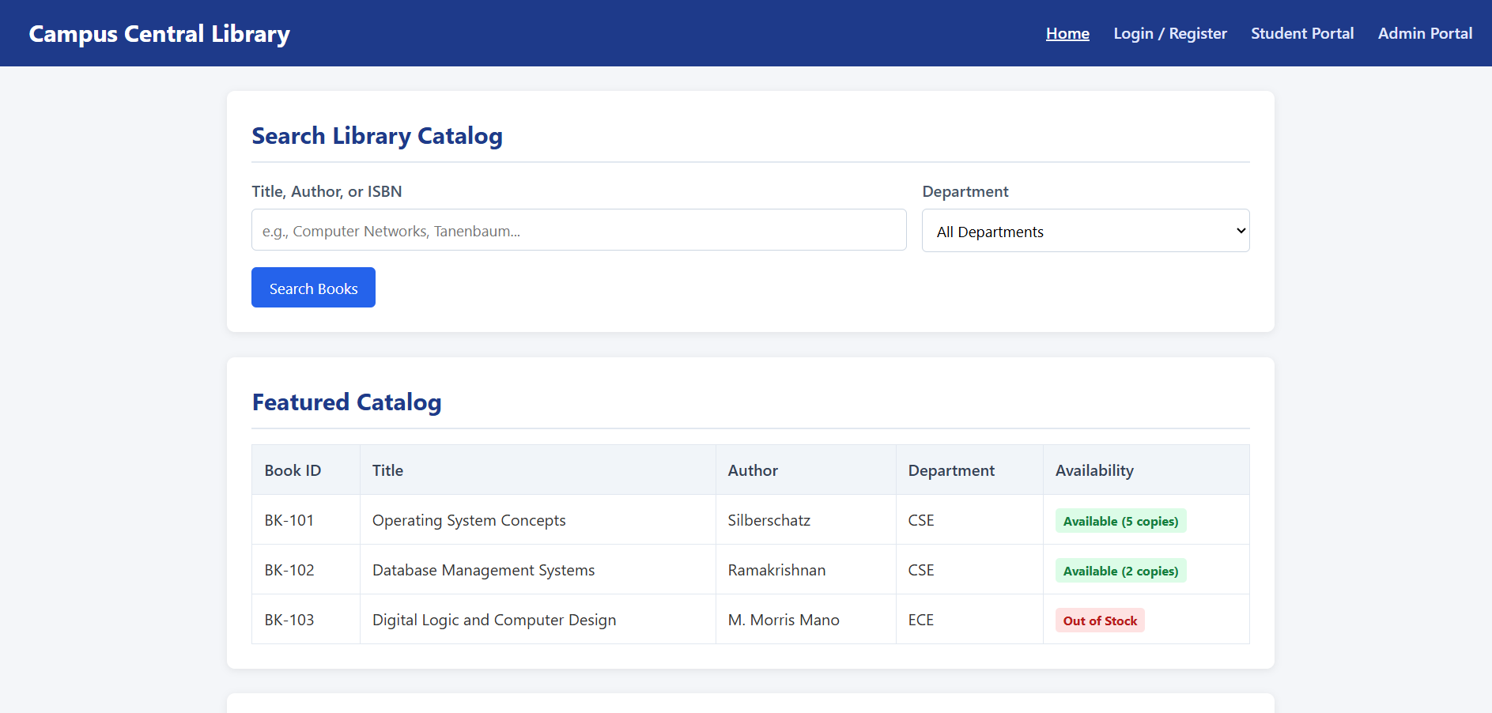
4. Result
Thus, the Online Library Management System was designed to help students search for books, view borrowing history, check fines, and download study materials. The librarian can manage books, issue and return records, calculate fines, and maintain study materials efficiently.

